Soft links (symbolic links) and hard links are two different ways to link files in Linux. Here's a breakdown of each:
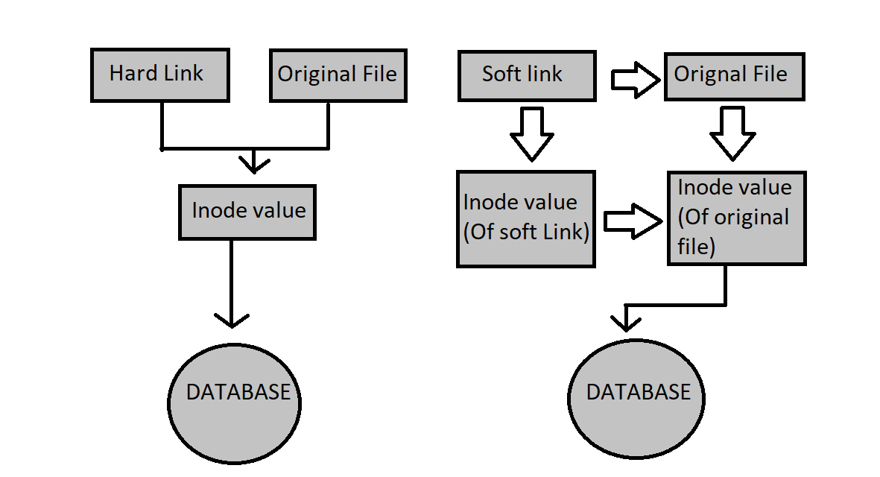
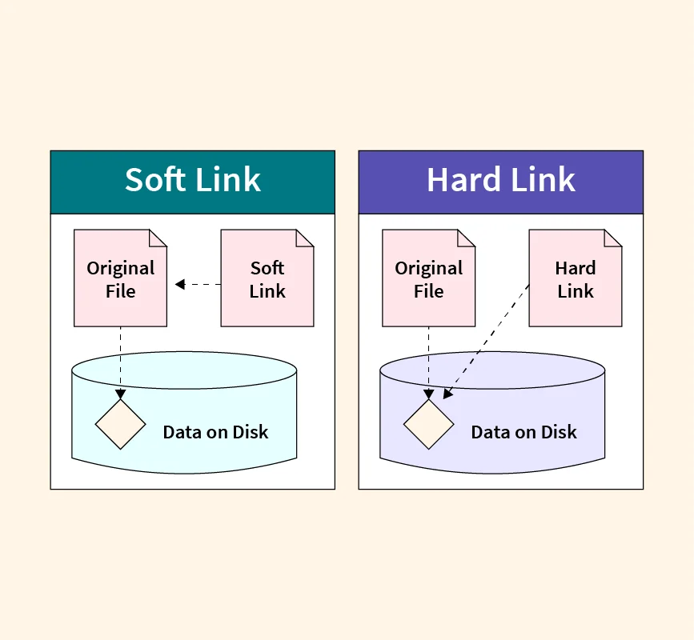

Soft Link (Symbolic Link):-
- Definition:
  - A soft link (or symbolic link) is a type of file that contains a reference to another file or directory in the form of an absolute or relative path.
  - It's similar to a shortcut in Windows.
- Creation:
  - Use the ln command with the -s option to create a soft link.

ln -s target linkname
- Characteristics:
  - If the original file is deleted, the soft link becomes a broken link (it points to a non-existent file).
  - Soft links can cross file systems.
- Example:

ln -s /path/to/original/file softlink
ln -s /home/ec2-user/file2 softlink

Hard Link :-
- Definition:
  - A hard link is a direct pointer to the data on the disk of the original file. Both the original file and the hard link share the same inode.
  - Multiple hard links to the same file are indistinguishable from one another.
- Creation:
  - Use the ln command without the -s option to create a hard link.

ln target linkname
- Characteristics:
  - If the original file is deleted, the hard link still maintains access to the file's data.
  - Hard links cannot cross file systems.
  - Both the original file and the hard link must be on the same file system.
- Example:

ln /home/ec2-user/file2 hardlink

Key Differences
Feature | Soft Link | Hard Link
Creation Command | ln -s target linkname | ln target linkname
Link to Directory | Allowed | Not Allowed
Cross File Systems | Yes | No
If Original is Deleted | Becomes a broken link | Remains accessible
Inodes | Different inodes for original and link | Same inode for original and link

Use Cases
- Soft Links: Useful for creating shortcuts to files or directories. Commonly used in package management and linking configuration files.
- Hard Links: Useful for creating backup copies of files without duplicating data. Ideal when you need multiple references to the same data within the same file system.
Application.yml - - - - java8version (jar version1) (version 1 soft link)
java8version (jar version2) (version 1 soft link)
java8version (jar version3)
What is an Inode?
“An inode is a data structure that contains metadata about a file or directory, excluding the file's name and its actual data content. Each file or directory on a filesystem is assigned a unique inode, which stores important information about the file.”

Information Stored in an Inode:-
An inode contains the following information:
- Inode Number (ID): A unique identifier for the inode within the filesystem.
- File Type: Indicates whether the file is a regular file, directory, symbolic link, etc.
- Permissions: The access permissions for the file (read, write, execute).
- Owner and Group: The user ID (UID) and group ID (GID) of the file owner and group.
- File Size: The size of the file in bytes.
- Timestamps: Information about the file's last access time, modification time, and inode change time.
- Link Count: The number of hard links pointing to the inode.
- Pointer to Data Blocks: Pointers to the disk blocks that store the file’s data.

How Inodes Work:-
- Linking Files and Inodes: When a file is created, it is assigned an inode number. The directory entry contains the filename and the corresponding inode number. The inode itself contains the metadata and pointers to the file data.
- Hard Links: Multiple filenames can point to the same inode. This is why you see the same inode number for both main.txt and myfile_hardlink in your example. Hard links are essentially additional directory entries that reference the same inode.
- Soft Links: Symbolic (soft) links are different as they create a separate inode that points to the pathname of another file.

